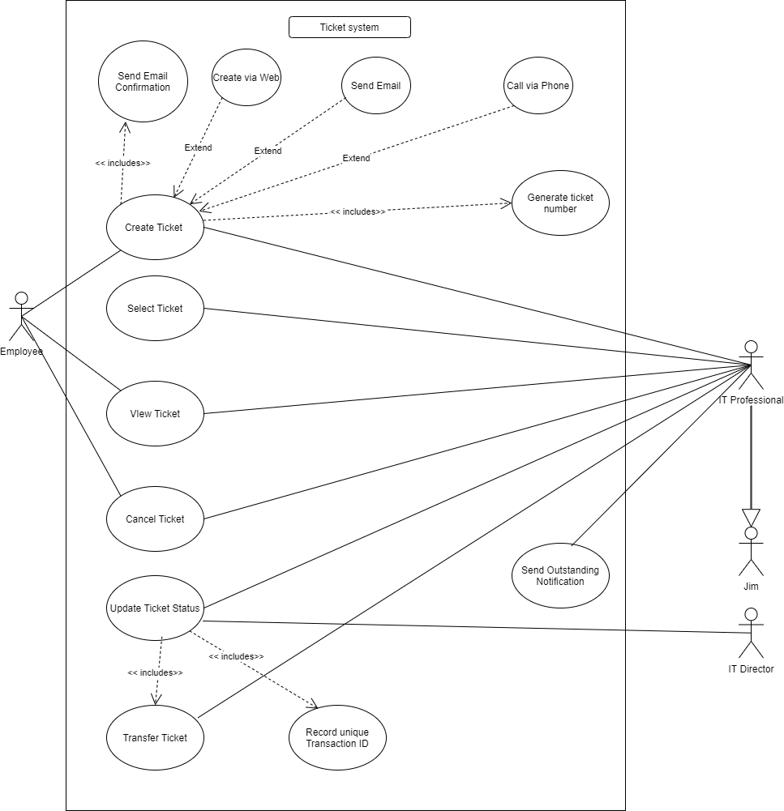

**CITM 305**

System Analysis and Design

**Group Project Part 1**

Ticket Module of Service Ticket System

**Group 4 - Group Members**

Jacqueline Chung - 500938284

Mena Yousuf- 500718788

Emelia Dizon - 500918326

Areeba Hassan - 500390065

Zackeria Izzeddin - 500847596

**Prepared For:**

Professor Dr.Upal Nath

*School of Information Technology Management*

Ted Rogers School of Management

**June 24, 2020**

Ryerson University

# Table of Contents

**Assumptions** **3**

**Use Case Assignment List** **4**

Use Case Diagram **5**

**Use Case Descriptions** **6**

Use Case: Create Ticket - Areeba Hassan 6

Use Case: Select Ticket - Jacqueline Chung 7

Use Case: View Ticket - Mena Yousuf 7

Use Case: Update Ticket Status – Zackeria Izzeddin 9

Use Case: Cancel Ticket - Emelia Dizon 10

**Activity Diagrams** **12**

Create Ticket Activity Diagram - Areeba Hassan 12

Select Ticket Activity Diagram - Jacqueline Chung 13

View Ticket Activity Diagram - Mena Yousuf 14

Cancel Ticket Activity Diagram - Emelia Dizon 15

Update Ticket Status Activity Diagram - Zackeria Izzeddin 16

**Domain Class Diagram** **17**

# Assumptions

Use Case Diagram

* There must be more than one IT professional in the department.
* A transaction ID will be recorded every time the ticket status changes.
* System keeps a record with a unique transaction ID, where it cannot be changed by anyone.
* Nicki Cardi is the IT director.
* Jim is a subset of an IT professional, as he is an IT professional.

Domain Class Diagram

* Every employee would have their own hardware; while only one hardware would be owned by an employee.
* Upgrade, Installation, Setup, and Replacement for SupportServices class.
* If the hardware is a laptop or desktop computer, then it should have an attribute of ScreenSize.
* Software and hardware can have zero or more SupportServices.
* The IT department offers SupportServices.
* IT professionals are assigned a ticket that is created by an employee.
* An employee may or may not have a ticket.
* An IT professional may or may not have a ticket.
* A ticket may be a phone, email, or website type.
* A ticket has a Transaction ID that can be updated.

# Use Case Assignment List

|  |
| --- |
| **Use Cases with Assigned Persons** |
| Create Ticket (Areeba) |
| Select Ticket (Jaqueline) |
| Update Ticket Status (Zackeria) |
| View Issue (Mena) |
| Cancel Ticket (Emelia) |

# Use Case Diagram



# Use Case Descriptions

## Use Case: Create Ticket - Areeba Hassan

|  |  |  |
| --- | --- | --- |
| **Use Case Name:** | Create Ticket | |
| **Scenario:** | Create a ticket in Ticket module | |
| **Triggering event:** | Employee creates a ticket | |
| **Brief description:** | In the Ticket module, Employee creates a ticket via email, phone or through the website. An automated email confirmation is sent to the employee when the ticket is created. | |
| **Actors:** | Employee  IT professional | |
| **Related Use Cases:** | Include:   * Automated Email Confirmation * Ticket added to the Ticket Pool | |
| **Stakeholders:** | Employees: Creates ticket with the issue identified  IT Professional: Creates ticket for employees who calls and report an issue | |
| **Preconditions:** | An employee having an issue with their hardware or software device | |
| **Postconditions:** | A ticket is created and added to the ticket pool. Next, the IT professional will select the ticket and try to resolve it. | |
| **Flow of Events:** | Actor | System |
|  | 1. Employee creates ticket via email, phone or through website | 1.1. Ticket is created  1.2. Ticket added to the Ticket Pool  1.3. Unique ticket number created  1.4. Automated email confirmation sent to the employee |
| **Exceptional conditions** | 1.4. The email address provided by the employee has an error which either doesn’t create the ticket or automated email confirmation doesn’t send. | |

## 

## Use Case: Select Ticket - Jacqueline Chung

|  |  |  |
| --- | --- | --- |
| **Use Case Name:** | Select Ticket | |
| **Scenario:** | Select list of tickets in ticket pool | |
| **Triggering event:** | Employee creates a new ticket | |
| **Brief description:** | Once an employee calls, emails, or uses the website to create a new ticket, the new ticket will be added to the ticket pool.  The IT professional will see a list of tickets and the ticket pool. If they do not have an existing ticket, they select a ticket on the top of the list.  Once the ticket is selected, it will be added to the professional’s to-do list, as well as the status will change from “New” to “Assigned”. | |
| **Actors:** | IT Professional | |
| **Related Use Cases:** | None | |
| **Stakeholders:** | Employees: Creates ticket with the issue identified  IT Professional: Selects the ticket and resolves it | |
| **Preconditions:** | A ticket is created by an employee and sent to the Ticket Pool. The IT professional logs into the ticket system.  The ticket is linked to the employee and IT professional. | |
| **Postconditions:** | A ticket is taken and the status of the ticket is changed. The ticket is added to the IT professional’s to-do list.  The ticket is linked to the IT Professional. | |
| **Flow of Events:** | Actor | System |
|  | 1.The IT professional selects ticket from top of the list. | 1.1. Ticket is added to To-Do List.  1.2. The status of ticket changes from “New” to “Assigned”.  1.3. Record unique transaction ID |
| **Exceptional conditions** | None | |

## Use Case: View Ticket - Mena Yousuf

|  |  |  |
| --- | --- | --- |
| **Use Case Name:** | View Ticket | |
| **Scenario:** | View issue described in ticket | |
| **Triggering event:** | Employee experience issues with hardware and software and requires IT professional assistance. | |
| **Brief description:** | Employee creates ticket to have IT professional investigate issue that they are experiencing with either their hardware and software.  IT professional looks over the ticket and attempts to resolve the issue. | |
| **Actors:** | Employee  IT professional | |
| **Related Use Cases:** | Attempt to solve the issue that the employee experiences | |
| **Stakeholders:** | Employee: Creates ticket with the issue identified  IT Professional: Selects ticket and attempts to resolve issue | |
| **Preconditions:** | Employee must experience issue with hardware and software that requires IT professional’s assistance. | |
| **Postconditions:** | IT professional must review the ticket and determines if they are capable of solving the issue or if they have to reach out to IT director for further assistance. | |
| **Flow of Events:** | Actor | System |
|  | 1. The employee submits a ticket outlining the issue.  2. IT professional views ticket to further investigate  3. IT professional attempts to resolve the issue.  4. IT professional is unable to solve the issue and seeks IT director for advice.    5. Employee receives notice that the ticket is either under review or redirected. | 1.1 Tickets are moved into the IT professionals queue under review.      4.1 Issue is either resolved or ticket is redirected back into the ticketing pool.  4.2 Ticket status is changed.  4.3 Transaction ID is changed. |
| **Exceptional conditions** | Minor hardware and software issue that gets resolved without the need for IT professional assistance, ticket is therefore no longer required and can be cancelled. | |

## Use Case: Update Ticket Status – Zackeria Izzeddin

|  |  |  |
| --- | --- | --- |
| **Use Case Name:** | Update Ticket Status | |
| **Scenario:** | Update Ticket Status from one status to another | |
| **Triggering event:** | Whenever an event occurs that requires the system to change the ticket status. | |
| **Brief description:** | The updating of ticket status by the system is in place to let the I.T professionals know what needs attention, needs to be done or is completed already. | |
| **Actors:** | IT professional  IT Director | |
| **Related Use Cases:** | Transfer ticket, record unique transaction ID, record ticket ID. | |
| **Stakeholders:** | Employee: Reports issue to system  I.T Professional: Selects ticket, resolves issues  I.T Director: changes ticket status | |
| **Preconditions:** | The Ticket must be selected  The Employee must exist | |
| **Postconditions:** | The Ticket status will be changed to “new”, “assigned”, “closed”, “cancelled” or “outstanding” | |
| **Flow of Events:** | Actor | System |
|  | 1. The IT professional logs on to the system and select a ticket  2. IT professional resolves issue  3. If the IT professional can’t complete the work, a request is sent to Jim and Nicki Cardi changes ticket status  4. When the employee reports issue and no longer needs it resolved, ticket status changes  5. If an issue takes longer than three days, the status is changed | 1.1. The system changes from “new” to “assigned”  2.1 System changes from “assigned” to “closed”  3.1 System changes ticket status will be changed from “Assigned” to “new”  4.1 System changes ticket status to “cancelled”  5.1 System changes ticket status to “outstanding” |
| **Exceptional conditions** | None | |

## Use Case: Cancel Ticket - Emelia Dizon

|  |  |  |
| --- | --- | --- |
| **Use Case Name:** | Cancel Ticket | |
| **Scenario:** | Employee cancels ticket | |
| **Triggering event:** | The employee no longer needs technical assistance | |
| **Brief description:** | If the issue is resolved employee will contact I.T professional through call or email to cancel the ticket. | |
| **Actors:** | Employee  IT professional | |
| **Related Use Cases:** | If employee problem arises again view ticket, and select ticket use case will be affected | |
| **Stakeholders:** | Employee: Initiates ticket cancellation request  I.T Professional: Processes ticket cancellation | |
| **Preconditions:** | The Ticket must exist.  The Employee must exist.  Ticket must be assigned to I.T professional. | |
| **Postconditions:** | The Ticket status will be changed to “cancelled”.  An email confirmation will be sent to the employee. | |
| **Flow of Events:** | Actor | System |
|  | 1. The employee will request cancellation of the ticket to the I.T department through call or email  2. I.T professional in charge of the ticket will receive the request | 2.1 Ticket status will be changed to “cancelled”  2.2 Ticket will be removed from the system  2.3 An email confirmation sent to the employee |
| **Exception Conditions** | None |  |

## 

# Activity Diagrams

## Create Ticket Activity Diagram - Areeba Hassan

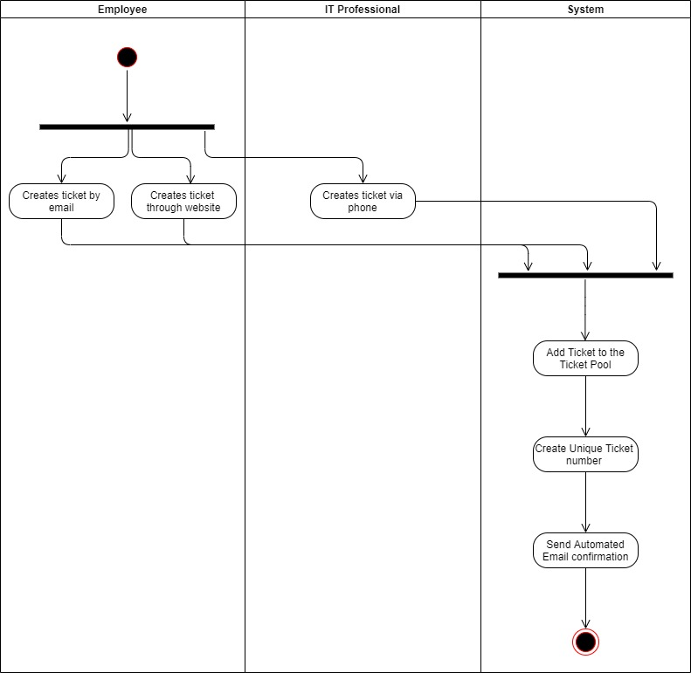

## 

## Select Ticket Activity Diagram - Jacqueline Chung

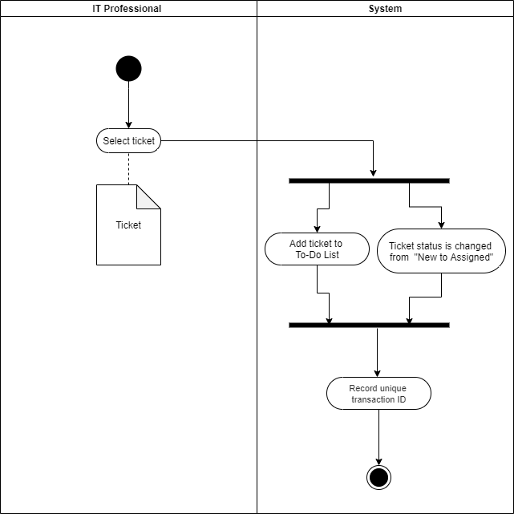

## 

## 

## 

## View Ticket Activity Diagram - Mena Yousuf

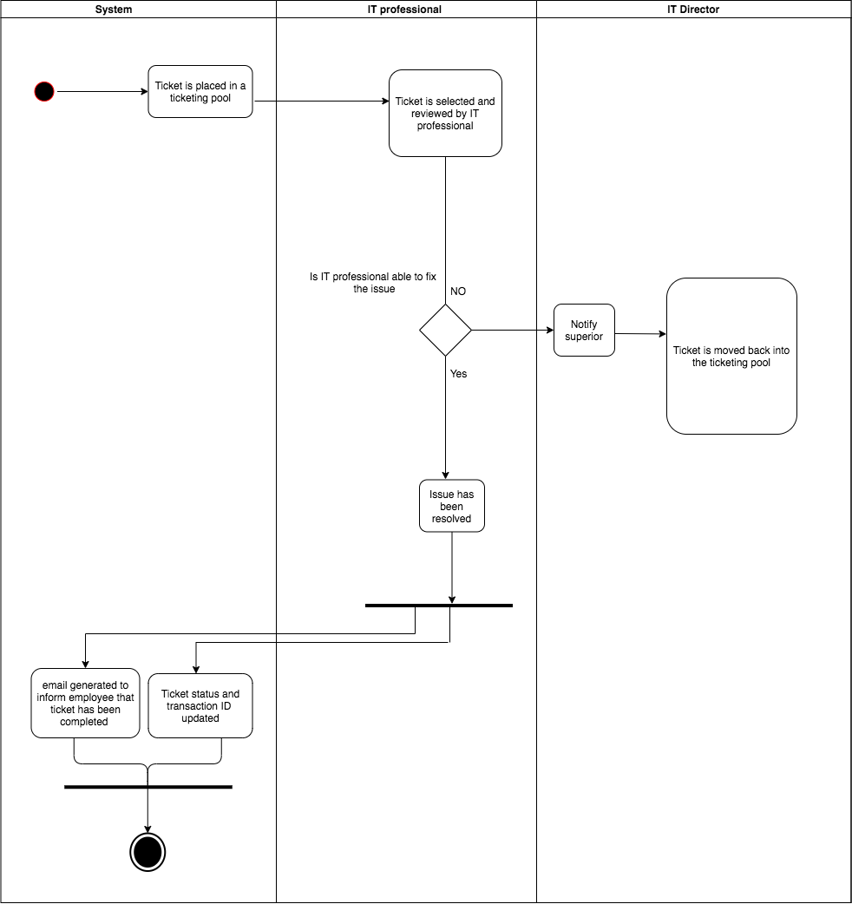

## Cancel Ticket Activity Diagram - Emelia Dizon

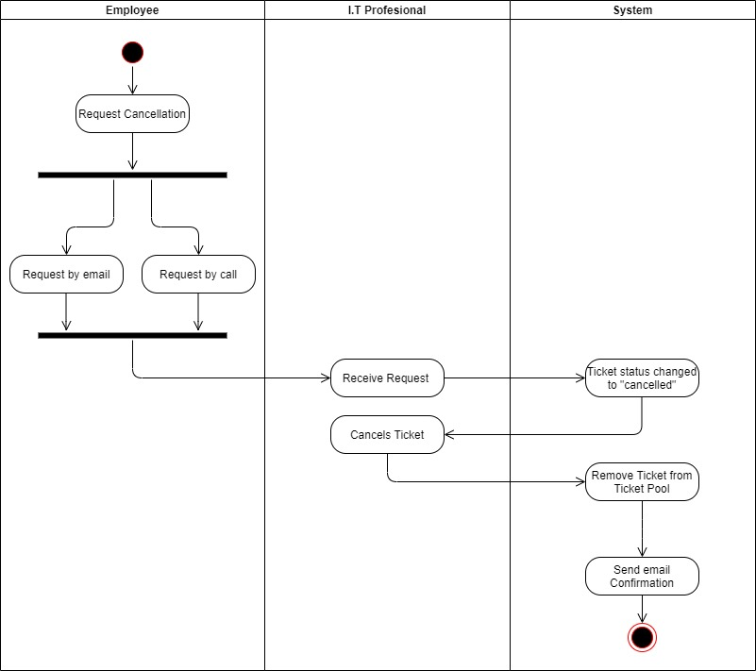

## 

## Update Ticket Status Activity Diagram - Zackeria Izzeddin

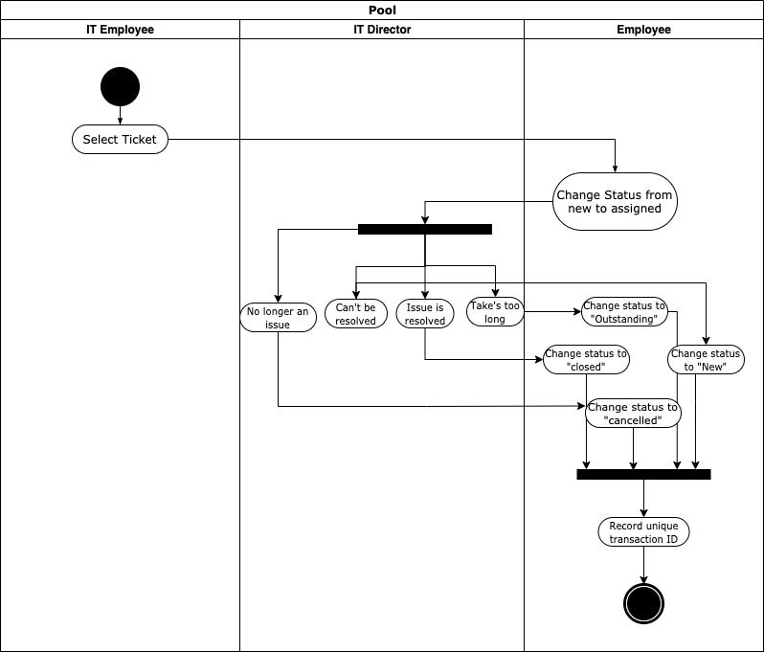

# Domain Class Diagram

